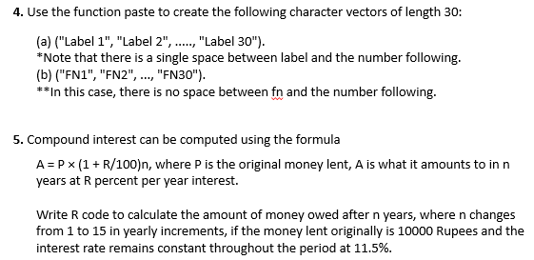

**Ans (a)**

> n="Label"

> paste(n,1:30,sep = " ")

[1] "Label 1" "Label 2" "Label 3" "Label 4" "Label 5" "Label 6" "Label 7"

[8] "Label 8" "Label 9" "Label 10" "Label 11" "Label 12" "Label 13" "Label 14"

[15] "Label 15" "Label 16" "Label 17" "Label 18" "Label 19" "Label 20" "Label 21"

[22] "Label 22" "Label 23" "Label 24" "Label 25" "Label 26" "Label 27" "Label 28"

[29] "Label 29" "Label 30"

**Ans (b)**

> p="FN"

> paste(p,1:30,sep = "")

[1] "FN1" "FN2" "FN3" "FN4" "FN5" "FN6" "FN7" "FN8" "FN9" "FN10" "FN11"

[12] "FN12" "FN13" "FN14" "FN15" "FN16" "FN17" "FN18" "FN19" "FN20" "FN21" "FN22"

[23] "FN23" "FN24" "FN25" "FN26" "FN27" "FN28" "FN29" "FN30"



**Ans**

> A=function(p,r,n){p*(1+r/100)^n}

> A(10000,0.1125,1:15)

[1] 10011.25 10022.51 10033.79 10045.08 10056.38 10067.69 10079.02 10090.36 10101.71

[10] 10113.07 10124.45 10135.84 10147.24 10158.66 10170.0

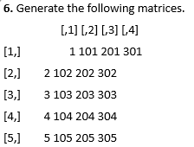

**Ans**

> r=matrix(c(1,2,3,4,5,101,102,103,104,105,201,202,203,204,205,301,302,303,304,305),nrow = 5)

> r

[,1] [,2] [,3] [,4]

[1,] 1 101 201 301

[2,] 2 102 202 302

[3,] 3 103 203 303

[4,] 4 104 204 304

[5,] 5 105 205 305

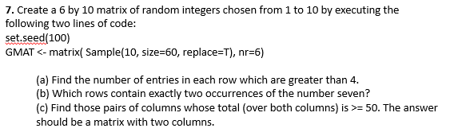

**Ans**

> GMAT=matrix(sample(10,size=60,replace=T),nr=6)

> GMAT

[,1] [,2] [,3] [,4] [,5] [,6] [,7] [,8] [,9] [,10]

[1,] 4 9 3 4 5 5 2 8 3 6

[2,] 3 4 4 7 2 10 7 9 4 3

[3,] 6 6 8 6 8 4 10 7 4 2

[4,] 1 2 7 8 9 10 2 5 2 3

[5,] 5 7 3 6 6 7 4 8 3 6

[6,] 5 9 4 8 3 9 9 9 3 3

**Ans (a) - 35**

> n=apply(GMAT,1,function(x)x>4)

> n

[,1] [,2] [,3] [,4] [,5] [,6]

[1,] FALSE FALSE TRUE FALSE TRUE TRUE

[2,] TRUE FALSE TRUE FALSE TRUE TRUE

[3,] FALSE FALSE TRUE TRUE FALSE FALSE

[4,] FALSE TRUE TRUE TRUE TRUE TRUE

[5,] TRUE FALSE TRUE TRUE TRUE FALSE

[6,] TRUE TRUE FALSE TRUE TRUE TRUE

[7,] FALSE TRUE TRUE FALSE FALSE TRUE

[8,] TRUE TRUE TRUE TRUE TRUE TRUE

[9,] FALSE FALSE FALSE FALSE FALSE FALSE

[10,] TRUE FALSE FALSE FALSE TRUE FALSE

**Ans (c) – Addition of any 2 columns is a total over 50**

> colSums(GMAT)

[1] 38 29 47 41 30 36 25 36 29 41

> s=colSums(GMAT)

> rbind(GMAT,s)

[,1] [,2] [,3] [,4] [,5] [,6] [,7] [,8] [,9] [,10]

5 5 6 9 1 10 6 1 1 10

7 5 10 1 6 3 2 4 6 1

10 3 7 5 8 4 1 6 9 10

7 7 7 6 3 5 8 7 9 8

5 5 9 10 4 10 4 10 1 3

4 4 8 10 8 4 4 8 3 9

s 38 29 47 41 30 36 25 36 29 41